Tamir, Zakariyya (1931- )

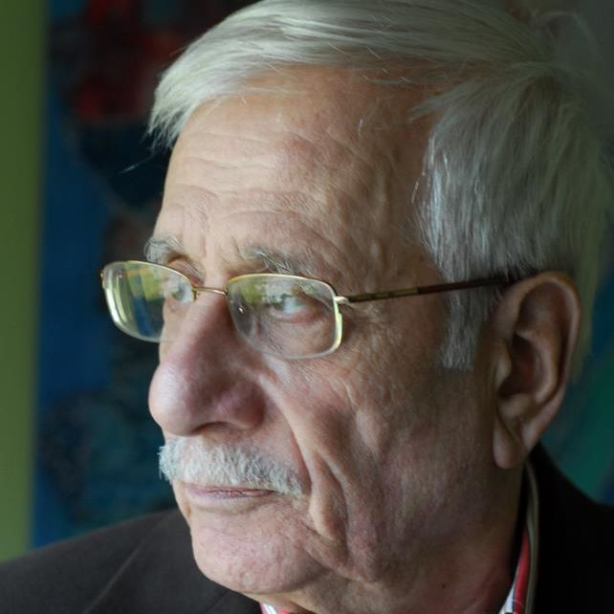

*Words are unfortunate, and doomed*

*they don’t feed the hungry,*

*don’t provide shelter to a displaced family,*

*don’t pull a prisoner out of jail,*

*don’t chastise a murderer*

*they don’t overthrow oppressors…*

*They don’t grant parks to the children,*

*schools to the illiterate and hospitals to the ill,*

*they don’t have weapons and gunfire to encircle the tyrants’ castles,*

*but they are unique in exhorting the oppressed to demand the lost liberty,*

*and to die for the cause of freedom.*

(Zakariyya Tamir, *Ard al-Wail*, 2015)

Born in Damascus in 1931, **Zakariyya Tamir** (Arabic [زكريا تامر] also transliterated Zakaria Tamer) is a renowned Syrian short-story writer, columnist and the author of numerous books for children. He grew up in the *al-Bahsa* district of the Syrian capital and received formal education until the age of 13 when he left school to work as a blacksmith in what was then the embryonic Syrian Republic, which had just obtained independence from France. As part of a larger wave of authors coming from peasant and working-class backgrounds that appeared in the Arab Middle East during the 1950s and 1960s, Zakariyya Tamir emerged as a short-story writer in the second half of the 1950s when he began publishing his novellas in *al-Nuqqad*, a Damascene literary magazine run by Sa’id al-Jaza’iri. The literary and cultural renaissance (known in Arabic as *al-nahda al-‘arabiyya*) that the Arab world had witnessed since the late eighteenth century had been hitherto represented almost exclusively by male writers coming from urban upper class settings. In this context the self-taught, unusual literary figure of Zakariyya Tamir gained prominence in the Syrian literary scene with works that since the outset have been characterised by a close focus on the vicissitudes of solitary individuals, and their struggle against social constraints.

Tamir’s first collection, *Sahil al-Jawad al-Abiyad* (*The Neighing of the White Steed*), was published in Beirut in 1960 and since then he has published ten compilations of short stories, three collections of satirical articles and various pieces in Arab periodicals. In the 1960s he actively participated in the establishment of the Arab Writers’ Union, was appointed editor of the literary magazine *al-Mawqif al-Adabi* and worked for the Syrian Ministry of Culture, as well as for the Syrian state television and the Saudi Arabian channel Jedda TV.

He gained international acclaim as a writer in the 1970s with his two most celebrated collections, *Dimashq al-Hara’iq* (*Damascus of Fires*, 1973) and *al-Numur fi al-Yaum al-‘Ashir* (*Tigers on the Tenth Day*, 1978) which are both characterised by vivid and evocative allegorical depictions of life under dictatorship and authoritarianism.

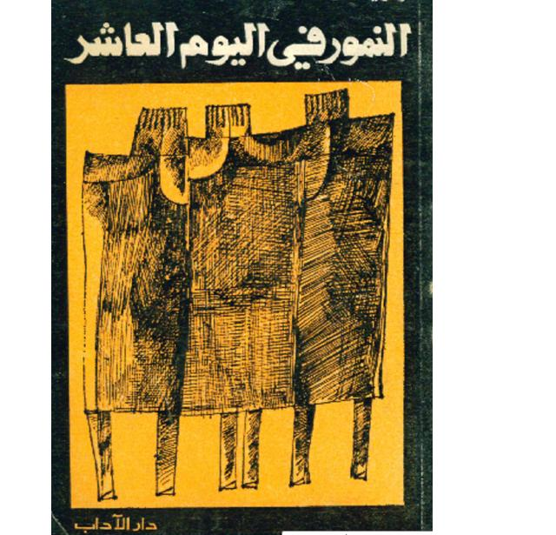 Cover of al-Numur fi al-Yawm al-‘Ashir (*Tigers on the Tenth Day*, 1978)

His oeuvre is characterised by a highly experimental linguistic style and an innovative blend of classical Arabic with popular and dialectical elements. Tamir’s language often mixes prose and poetry and the Syrian dialect frequently appears. He writes in a simple *fusha* amalgamated with some colloquial words and coloured with an identifiable local touch. Maintaining this balance, he has participated in shaping modern Arabic literature while expressing a distinctive Syrian national character.

[insert video link: <https://archive.org/details/zakariya-tamer-realite-lundis-litteraires-ifpo-5>]

Between the 1970s and 1980s Tamir’s works were circulated widely across Europe and translations into Russian, Italian, Spanish, French, English and German were published, often accompanied by introductions containing bright albeit brief insights into his style and the significance of his short stories. In the early 1980s, during a period of huge political turmoil in Syria, the state’s censorship’s of his satirical articles and a general feeling of estrangement from the environment in Damascus made him take the unexpected decision to leave Syria. In 1981 he left Damascus with his family. He would have moved to neighbouring Lebanon if it were not for the unstable situation caused by the Lebanese civil war. Instead, he moved to London, where he has worked for various literary magazines of the Arab diaspora such as *al-Tadamon*, *al-Dustour* and *al-Naqid*. A 16-year-long literary silence followed Tamir’s first years in England and it was only in 1994 that he returned to the scene with *Nida’ Nouh* (*Noah’s Summon*), a compilation of thirty-six new short stories followed by *Sa-nadhak* (*We Shall Laugh*) in 1998, *al-Hisrim* (*Sour Grapes*) in 2000, *Taksir Rukab* (*Breaking Knees*) in 2002 and *al-Qunfuz* (*The Hedgehog*) in 2005, all of which were published for the Lebanese London-based Riyad el-Rayyes Books. For the same house he has also published *Haja’ al-Qateel ‘ala Qatili-hi* (*The Victim’s Satire of His Killer*) a collection of satirical articles that appeared in 2003. He has lived in Oxford since the late 1990s and until 2011 he visited Syria every year. In 2012, at the age of 81, Tamir symbolically joined the Syrian revolution against the regime of Bashar al-Assad with a Facebook page called *al-Mihmaz* (Arabic for ‘the spur’) where he publishes very short stories and brief comments not only satirising the government with metaphors and allegories, but also mentioning its members, the Syrian president and other key figures explicitly. His last book *Ard al-Wail* (*The Land of Misery*) published for Jadawel in 2015 is another collection of satirical articles.

The snow

“Right now snow is falling profusely in the UK, and kids rush to make several snowmen, and they stick a carrot in their faces to make their noses. Syrian kids make a snowman that looks like Bashar al-Assad, and they stick the largest carrot they can find in a place far from the nose. ” (From *al-Mihmaz*, December 2012)

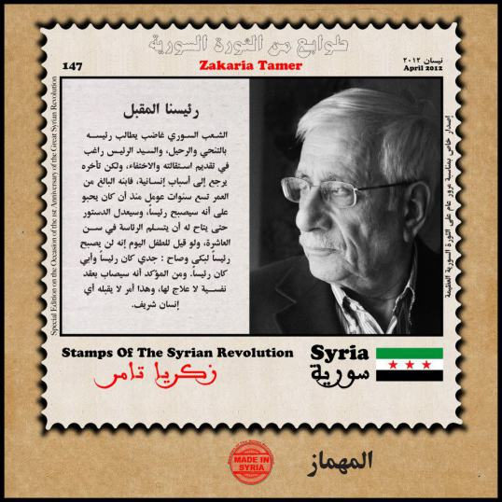

Stamp of the Syrian revolution dedicated to Zakariyya Tamir’s *al-Mihmaz*, by the Syrian artist Ammar al-Beik, published on http://www.creativememory.org/

List of Works:

Collections of short stories:

- Sahil al-Jawad al-Abiyad*,* (*The Neighing of the White Steed*), Dār Majallat Shiʻr, Beirut, 1960 (صهيل الجواد الأبيض)

- Rabi’ fil Ramad, (*A Spring in the Ashes*)*,* Maktaba al-Nuri, Damascus, 1963

(ربيع في الرماد)

- al-Ra’d, (*the Thunder*), the Arab Writers’ Union, Damascus, 1970 (الرعد)

- Dimashq al-Hara’iq*,* (*Damascus of fires*)*,* Maktaba al-Nuri, Damascus, 1973

دمشق الحرائق))

- al-Numur fil yawm al-‘Ashir, (*Tigers on the Tenth Day*),1978, Dar al-Aadab, Beirut اليوم العاشر) النمور في)

- Nida’ Nuh,(*Noah’s Summons*), Riyad el-Rayyes Books, Beirut, 1994 نداء نوح) )

*-* Sa-Nadhak*,* (*We Shall Laugh*), Riyad el-Rayyes Books, Beirut, 1998 (سنضحك)

*-* al-Hisrim,(*Sour Grapes*), Riyad el-Rayyes Books, Beirut, 2000 (الحصرم)

- Taksir Rukab,(*Breaking Knees*), Riyad el-Rayyes Books, Beirut, 2002 (تكسير ركب)

- al-Qunfuz,(*The Hedgehog*), Riyad el-Rayyes Books, Beirut, 2005 (القنفذ)

Compilations of satirical articles:

* Amjad, ya ‘Arab, Amjad, *(Glories, Arabs, Glories)*, 1986 (أمجاد يا عرب أمجاد)
* Haja’ al-Qateel ‘ala Qatili-hi, (*The Victim’s Satire of his Killer*), Riyad el- Rayyes Books, Beirut, 2003 (هجاء القتيل على قاتله)
* Ard al-Wail, (*The Land of Misery*), Jadawel, Beirut, 2015 (أرض الويل)

Translations in English:

* Zakaria Tamer, *Tigers on the Tenth Day and other stories*, trans. by Denys Johnson-Davies, Quartet, 1985
* Zakaria Tamer, *Breaking Knees*, trans. by Ibrahim Muhawi, Garnet, 2008
* Zakaria Tamer, *The Hedgehog*, trans. by Brian O’Rourke and Denys Johnson-Davies, American University in Cairo Press, 2009

Further reading:

- Dr. Ibrahim al-Jaradi, ed. by, *Zakariyya Tamir: masamir fi khashab al-tawabit,* The Arab Writers’ Union,Damascus, 2011

- Imtinan ‘Uthman as-Samadi, *Zakarya Tamir wa-al-qissah al-qasirah*, Wizarat al-Thaqafa, Amman, 1995

- *Aff! Zakariyyā Tāmir – Mukhtārāt qisasiyyah*, Al-hay’a al-ʽāmma la-quṣūrath-thaqāfa, Cairo, 1998. Afterword by Sabry Hafiz

-“La femme envie de Zakaria Tamir” by Eric Gautier in *La Syrie au présent: reflets d'une société*. Sous la dir. de Baudouin Dupret, ZouhairGhazzal, Youssef Courbage, Mohammed al-Dbiyat, [Sindbad-ActesSud](javascript:__doLinkPostBack('','ss%7E%7EPB%20%22Sindbad%2DActes%20Sud%22%7C%7Csl%7E%7Erl','');), Arles. 2010

-“Individuation and literature: Zakariyyā Tāmir and his Café Man” by Emma Westney in *Marginal voices in literature and society: individual and society in the Mediterranean Muslim world*. Volume directed by Robin Ostle: [European Science Foundation (ESF), in collaboration with the Maison Méditerranéenne des Sciences de l'Hommed'Aix-en-Provence](javascript:__doLinkPostBack('','ss%7E%7EPB%20%22European%20Science%20Foundation%20%28ESF%29%2C%20in%20collaboration%20with%20the%20Maison%20Méditerranéenne%20des%20Sciences%20de%20l%5C%27Homme%20d%5C%27Aix%2Den%2DProvence%22%7C%7Csl%7E%7Erl','');), Strasbourg , 2000

- “El rio esta muerto de Zakariya Tamir” by Mercedes Aragon Huerta in [Al-Andalus - Magreb](javascript:__doLinkPostBack('','ss%7E%7EAR%20%22Al%2DAndalus%20%2D%20Magreb%22%7C%7Csl%7E%7Erl','');), 1998, Vol. 3 Issue 1995

-“Notas acerca de la narrativa breve de Zakariya Tamir” by Jose Ramirez del Rio in Miscelanea de estudios arabes y hebraicos: seccion de arabe, 2003, vol.52

- “Un hombre para una mujer unica” by Mercedes Aragon Huerta in Anaquel de estudios arabes, 2001, vol. 11

Interviews:

-“Muqabala ma’ Zakariyya Tamir” in al-Ma’arifa, 126, August 1972, page 108-116

-“A dialogue with Zakariya Tamir” by Ziyad Majed on www.freesyrian translators.net, 5 June 2012 (http://goo.gl/AyLTzq)

Video:

- Lecture by Zakaria Tamer at the French Institute of the Near East, Damascus https://goo.gl/ZrjxWe